Policymakers and private industry has been pushing for a change in healthcare reimbursement policy. Back in January of 2015, several of the nation’s largest health care systems and payers, joined by purchaser and patient stakeholders, announced a powerful new private-sector alliance dedicated to accelerating the transformation of the U.S. health care system to value-based business and clinical models aligned with improving outcomes and lowering costs. The Health Care Transformation Task Force, whose members include six of the nation’s top 15 health systems and four of the top 25 health insurers, challenged other providers and payers to join its commitment to put 75 percent of their business into value-based arrangements that focus on the Triple Aim of better health, better care and lower costs by 2020.

[](http://www.google.com/imgres?imgurl=http://blog.theravid.com/wp-content/uploads/2013/06/healthcare_money-550x310.jpg&imgrefurl=http://blog.strivelabs.com/2013/06/26/no-value-based-reimbursement-in-physical-therapy-yet/&h=310&w=550&tbnid=4Q-coScwtvrtZM:&zoom=1&docid=a2cUkTmvOad-_M&ei=pHo-VeuAKYSHyQTPjoDAAg&tbm=isch&ved=0CCkQMygMMAw)The Task Force’s announcement came just two days after former Secretary of Health and Human Services Sylvia Mathews Burwell announced that Medicare would shift 50% of its provider payments into alternative payment arrangements such as accountable care organizations or bundled payments by 2018. Together, the two announcements send a clear signal that the public and private sector are aligning around a new trajectory for health care payments that moves away from fee-for-service and into alternative payment models also known as “Value Based Reimbursement” (“VBR”).

In this effort to meet the health care needs of an aging population, both providers and health plans are being forced to move away from traditional fee-for-service (FFS) reimbursement into **Value-based reimbursement (VBR).** VBR is designed to shift the basis of reimbursement from “volume to value” by incorporating financial incentives to improve clinical outcomes and performance. However, simply changing financial incentives is not sufficient to achieve the transformation. That transformation will require a holistic approach to VBR that includes a new emphasis on population health, care coordination, new alliances between health care organizations, physician offices/clinics, and investments in new tools and services. The provider organizations, the foundation to VBR is the requirement to upgrade community-based EHRs to truly integrated enterprise–wide EHRs designed to capture patient data from any clinical site, normalize the data, and presents the data in a format that is acceptable to physicians. Second. Providers must create comprehensive care coordination and patient engagement programs designed to create real time clinical for providers of care. For Health plans, the foundation is the development of strong next generation clinical business intelligent tools to go along with the current claims adjudication systems plus the need to create real-time care coordination programs designed to engage their members and the treating physicians.

One of the major challenges in the VBR financing system is a lack of knowledge on what technologies are required and at what phase. At AC Group, Inc., we have reviewed and evaluated over 100 technology software and services companies that claim they are providing “Population Health” technologies designed to lower costs and improve overall; health outcomes. The problem for most decision makers is that when you look at the offerings of the 100+ vendors, you get about 60 different offerings and very few are designed around needs of today and the future. The problem today is that vendors are claiming they sell a product or services that are needed in the industry without first defining the real needs of the specific organization. For example, it’s like selling “transportation” – do you need new shoes to walk, a skateboard, a 2-passager auto, a truck, a boat to go across water, or an airplane to move people and supplies across regions. We must first determine our needs and then match those needs to the multiple suppliers.

Clinical Decision makers need the right information, provided at the right time, about the right patients, with the right clinical rules and guidelines, on the right devices. To assist both Payers and Providers, AC Group came up with a road map designed to help organizations with a clear plan for future technologies, required to thrive in the VBR marketplace. The ***7 Stages of VBR*** follows the same structure as the **HIMSS EMRAM 7 Stages** for EHR adoption. In this case, we start with the EHR as the base foundation (level 0) and we add additional functionality in a uniformed and logical manner. Starting from the bottom and working up, healthcare organizations interested in VBR financing models, must have the ability to connect multiple EHR products together from multiple vendors in order to create a 360-view of the patient’s condition over time, including not only clinical data but also cost data. (Stages 1-2). Then moving up the roadmap, the next 5 Stages (aka Population Health) requires each Stage to be accomplished and then additional stages can be added over a period of 2 to 5 years. The goal is to improve overall patient specific outcomes at a lower costs by applying best practice clinical alerts based on scientific data after the development and implementation of Care Coordination with Risk Stratification (Stage 3), Care Gaps (Stage 4), direct patient engagement (Stage 5), and remote patient monitoring capture of clinically important data (Stage 6) that is directly integrated back into the providers’ EHR (Stage 7). Of course, we believe the cost for each stage must be justified and tied to outcomes, quality improvement, and financial goals. Additional, new and advanced technology will be needed for each Stage and based on our evaluation of over 100 vendors that claim they have Population Health software, we do not believe most vendors can provide all 7 Stages. In fact, our December 2016 evaluation indicates that most vendors cannot even consolidate patient EHR data from multiple clinical sites, especially when multiple EHR integration is required. Many of the vendors provide portions of the 7-Stages of VBR, but without a true roadmap, it appears that mist provider organizations will not have the quantified clinical and financial data to thrive in the VBR financial marketplace.

Specifically, the 7-Stages of VBR can be briefly described as:

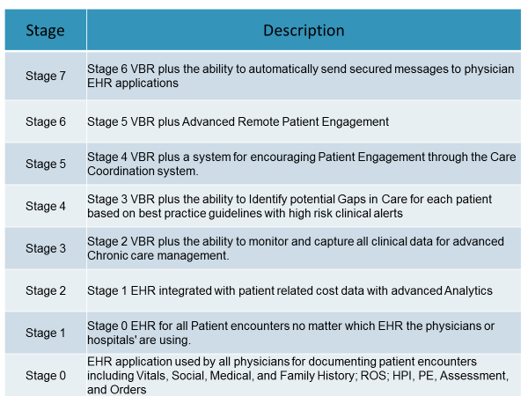

On February 20, 2017, AC Groups plans on releasing a detailed description of each of the 7-Stages of VBR which will include from 10-15 specific functions related to each Stage. This tool can be used by provider and payer organizations to evaluate how well a specific Population Health Vendor is positioned to meet all of the functional required necessary to thrive in the VBR marketplace.

Of course, since providers use different patient naming conventions and do not always collect the right information, the healthcare organization needs the ability to match patient (Master Patient Index) and the ability to cleanse the data so that garbage is removed from the patient single 360 view of the patient’s record. Once you have the single view of the patient’s clinical and financial records, you can create patient registries and you can start analyzing your population based on clinical rules and guidelines (Population Health). This is where 40% of the so called “population health” vendors in the market stop. The vendors highlight patient populations, costs, outliners, and help determine which physicians follow protocols. However, most so-called “population health” vendors do not provide actionable items directed to care providers on what necessary steps are required to improve clinical outcomes.

As far back as June of 2007, the [Agency for Healthcare Research and Quality (AHRQ)](http://www.ahrq.gov/)[1] identified over 40 definitions of care coordination and related terminology, and developed a working definition drawing together common elements. Overall, AHRQ defined Care Coordination as the “deliberate organization of patient care activities between two or more participants (including the patient) involved in a patient's care to facilitate the appropriate delivery of health care services. Organizing care involves the marshalling of personnel and other resources needed to carry out all required patient care activities, and is often managed by the exchange of information among participants responsible for different aspects of care”. This definition is adequate, but how does an organization implement Care Coordination without the right technologies. The simple answer is, “It Can’t”.

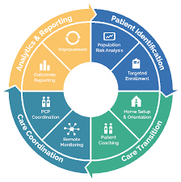Advanced Care Coordination requires single source of patient data, risk stratification, clinic alerts and guidelines based on best practices and all of this information needs to be presented in a simple manner that notifies the Care Coordinators about gaps in care and high risk patients that need action “today”. Care Coordinators do not need a list of 500 patients that meet certain criteria, they need daily worklist of high risk patients that need intervention today based on selected criteria and a list of patients that need intervention tomorrow. A care Coordinator cannot interact with 500 patients in one given day, so the advance software most priorities the patients based on criteria established by the various paying sources – usually Medicare or Health plans.

Once the Care Coordinators are provided a short list of patients to interact with on a daily basis, the Care Coordinators need instructions on what additional information is needed from either the patient or their family (Patient Engagement). This could be in the form of on-line questionnaires and remote monitoring of patients via home monitoring devices or even new inventions like Fit-Bit. Once the additional patient related data is collected, the next generation VBR software should recalculate the patient’s risk score and should create an updated patient specific care Coordination plan for the patient. Depending on the results, clinical alerts should be automatically electronically transmitted to the appropriate physician’s EHR software application in the form of a clinical message or alert. For effective Transition of Care, the physician should not have to log into a separate software application. The physician works within their EHR and should not have to leave their EHR to get clinical updates on their patients.

Now all of this might should great, but does Care Coordination and VBR technology really increase the chance of success? First, let’s look at the August 25, 2016 CMS announced regarding the 2015 financial and quality performance results for 392 ACOs. The results showed:

* 83 ACOs had health care costs lower than their benchmark, **but did not qualify** for shared savings, as they did not meet the minimum savings
* An increasing proportion of ACOs have generated savings above their minimum savings rate each year. For PY15, 31 percent of ACOs (120 of 392) generated savings above their MSR compared to 28 percent (92 of 333) in PY14 and 26 percent (58 of 220) in PY13.
* ACOs with more experience in the program were more likely to generate savings above their MSR. For performance year 2015, 42 percent of ACOs that started in 2012 generated savings above their MSR, compared to 37 percent of 2013 starters, 22 percent of 2014 starters and 21 percent of 2015 starters.
* 45 percent of ACOs participating in the Advance Payment model or ACO Investment Model tested by the Center for Medicare and Medicaid Innovation, which offer select Shared Savings Program ACOs pre-paid savings, generated savings above their MSR compared to 29 percent of all other ACOs.

The one factor that was missing from the discussion related to “how does advanced technologies drive financial and clinical improvements”. Our research indicates that the ACOs with the best results had advanced VBR software technologies that preformed almost all of the 7 Stages of our VBR functionality table on page 3. Although not involved in many of the ACO programs, AC Group have been involved in numerous projects where Advanced VBR technologies were used to improve clinical quality outcomes while reducing overall costs.

|  |
| --- |
| **Case Study 1 – Health Plan with 500,000+ covered Lives** |

A Health Plan in Southern California decided that they wanted to create a pay-for-performance program for local providers based on reducing costs while improving quality outcomes for their higher risk patients with chronic diseases. Prior to implementing and advanced VBR software application, the health plan relied on 90-day old adjudicated claims for their risk adjusted evaluations. They realized they need more data. The operational plan called for the consolidation of real-time patient specific clinical data from their active 2,300 providers including lab results, active medications, problem lists, allergies, vital signs, ER visits and Hospitalization, immunizations, and other data that could be collected from the national C-CDA interoperability standard. The Health Plan evaluated 12 vendors and selected a vendor that could provide 1 – One common view of risk stratified consolidated cleansed patient data from over 25 different EHRs with a Master Index to insure data integrity, 2 – Advance data analytics so that the healthcare plan could create disease registries so that they could identify gaps in care based on best practice clinical guidelines, 3 – a comprehensive Care Coordination program for identifying recent discharged patients from local Emergency Rooms and Hospitals and best practice guidelines for patients with COPD and Diabetes, 4 – a interactive patient and family engagement program to encourage patient compliance with clinical protocols, and last, 5 – the ability to passed clinical results back to individual physician’s EHR applications to gain trust within the physician population and to encourage physician interaction with the health pans Care Coordination program. Within 12 months the results were:

1. Integration of multiple structured and unstructured data streams to create one intelligent real-time view of the patient’s clinical data and current treatment plans and assignment to clinical care coordinators based on risk factors.
2. Better prediction of disease frequencies by mapping external factors at the city and county level using search trends, demographic patterns, and physical factors like obesity, smoking etc. while identifying key factors over time that enabled data-driven intervention plans.
3. Reduced ER re-admission rates within 48 hours by 42%
4. Reduced Hospital Re-admission rates within 96 hours by 67%.
5. Improved quality scores for COPD and Diabetes by implementing advanced clinical Care Coordination guidelines and working with local care providers. Results included in a reduction of diabetes patients with uncontrolled H1C values > 9.0 by 38%, improved compliance with annual eye and foot exams by 78%, and through education and patient engagement, reduced BMI scores by 12.5% for patients with Diabetes.
6. 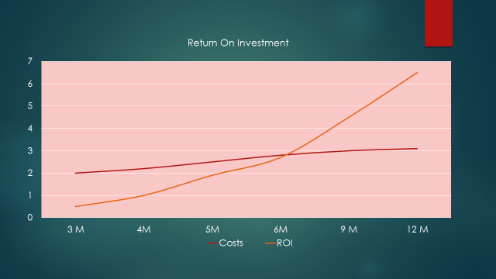The health plan calculated a return on Investment of 3x within 12 months of implementation.

|  |
| --- |
| **Case Study 2 – Health Plan with 325,000+ covered Lives** |

A Health Plan in the Mid-West that wanted to reduce the costs of Emergency Rooms and Hospital readmission through the development of a predictive modeling program designed to foresee readmission based on patient conditions and home conditions through an advanced patient engagement care coordination program. Prior to implementing and advanced VBR software application, the health plan relied on 90-day old adjudicated claims for their risk adjusted evaluations. Like the prior case study, they realized they needed more data. The operational plan called for the consolidation of real-time patient specific clinical data from the 12 hospitals in their geographic area including reason for admission, discharge plans, order results, discharged medications, and other clinical and operational data. The Health Plan evaluated 6 vendors and selected a vendor that could provide 1 – One common view of risk stratified consolidated cleansed patient data from over 6 hospital systems with a Master Index to insure data integrity, 2 – Advance data analytics so that the healthcare plan could create a comprehensive Care Coordination program for identifying recent discharged patients from local Emergency Rooms and Hospitals and best practice guideline, 3 – a interactive patient and family engagement program to identify risks of readmission, and last, 4 – the ability to passed clinical findings and guidelines back to individual physician’s EHR applications to encourage physician interaction with the health pans Care Coordination program. The results were:

1. Within 3 months the health plan had Integrated patient information from all 6 hospitals and created an intelligent real-time view of patient information and were able to assigned risk stratified patients to specific care coordinators based on their clinical expertise.
2. Reduced ER re-admission rates within 48 hours by 23% within 6 months and by 37% within 12 months.
3. Reduced Hospital Re-admission rates within 96 hours by 18% within 6 months and 42% within 12 months.
4. Reduced Medical Loss Ratio (MLR) by 34% for patients with risk of readmission.
5. These improvements in financial performance created a 6x return on investment on their advanced VBR software costs within 12 months.

|  |
| --- |
| **Conclusion** |

Advanced VBR software is not only necessary but required for both Payers and Providers in order to thrive under a VBR financial model. To thrive in this new market, payers and providers must start with data integration from multiple sources, implement advanced analytics and Care Coordination programs based on best practices and national care guidelines, and should implement patient and family engagement programs. To accomplish these fundamental requirements and to thrive in the new VBR financial models, Payers and Providers should search for software vendors that meet all the functionality requirements of the 7-Stages of VBR, since you will need a minimum of 12 months of prior patient data for true risk stratification, the time to buy advanced VBR software is today. But you don’t need all 7-Stages initially. The 7-Stages of VBR is a roadmap for the next 3-5 years. However, each stage must work interactively with prior and future stages, otherwise your healthcare organizations will be wasting money. Remember, Medicare VBR contracts equaling 50% of Medicare Payments are expected to being on October 1, 2017 followed closely by commercial insurance plans in early to late 2018. So the time to start evaluations is now and any delay in decision making will probably lead to poor VBR contracting results and lost profits.

|  |
| --- |
| **More about the Author** |



Mr. Anderson is a former CIO for 5 IDNs, an interim CFO and CEO of Rural Hospitals, is one of the nation's premier healthcare futurists and is one of the leading national speakers on healthcare who has spoken at over 1,000 conferences and meetings since 2000. Mr. Anderson has spent the last 43+ years focusing on Healthcare – not just technology questions, but strategic, policy, and organizational considerations. Mr. Anderson has extensive experience in health care redesign and organizational restructuring along with a comprehensive background in start-up and replacement of multi-facility health information platforms, including financial, clinical, managed care and decision support systems. Mr. Anderson specializes in the evaluation, selection, and ranking of vendors in the RCM, HIE, and PMS/EHR hospital and physician healthcare marketplace. Annually he publishes a detailed report on HIE and PMS/EHR software product functional, usability, and company viability.

His experience includes 17 years with multi-facility Health Care organizations, 15 years Administrative Executive Team experience, 6 years as a member of the Corporate Executive Team, and 9 years in healthcare turnaround consulting. Mr. Anderson received his BS in Business, is completing his MBA in Health Care Administration, and is a Fellow with HIMSS.

1. <https://www.ncbi.nlm.nih.gov/books/NBK44015/>